2APHY: Nuclear Physics Mid Unit Test
Name: __________________________________________________ (33 marks + overall = 34 marks)
OVERALL: Additional 1 mark for units and significant figures.
- Complete the table below: (2 marks)

Element | Nuclide | Atomic Number | Number of Neutrons | Mass Number
Nitrogen - 14 | 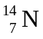 | 7
 |  | 2 | 2
 | 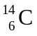 | 6 |  | 14

- Fully explain what an isotope is using examples. (3 marks) _________________________________
_________________________________________________________________________________
_________________________________________________________________________________
_____________________________________________________________________________________________________________________________________________________________________________________________________________________________________________________________________________________________________________________________________________________________________________________________________________________

- For each of the following, name the radiation emitted, its symbol and what the radiation is and what will stop it. [Level 4] (3 marks)

Nuclear Equation | Nuclide | Radiation name | Symbol | What is the radiation made of?
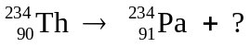
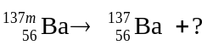
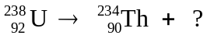

- A radiographer wants to investigate blood circulation in a patient. There are a number of radioisotopes available. What properties would you look for to select one? Give three reasons.
(3 marks)

________________________________________________________________________________
________________________________________________________________________________
________________________________________________________________________________
________________________________________________________________________________
________________________________________________________________________________
________________________________________________________________________________
________________________________________________________________________________
- Within a nuclear reactor, uranium-235 is bombarded by a neutron to split into two daughter products also emitting three neutrons. Part of the nuclear equation is shown below.

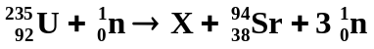

  - Write the nuclide for the missing daughter product labelled X. __________________ (1 mark)
  - What is the atomic and mass numbers of the daughter product X:
Mass no. ____________ (1 mark) Atomic no. _____________ (1 mark)

- A physics student has three radioactive sources, X, Y and Z. One is a pure α emitter, one is a pure β emitter and one is a pure γ emitter. He uses the following apparatus to decide which is which. The apparatus consists of a holder for the source, a sheet of thin aluminium foil placed in front of the source, a region of magnetic field directed into the page, and three detectors, 1, 2 and 3, arranged as shown below. The student is also told that charged particles will be deflected to the left or to the right when passing through a magnetic field.
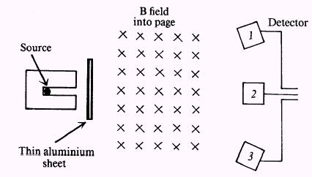
With source X there is no signal from any detector. With source Y there is a signal from detector 3 only. With source Z there is a signal from detector 2 only.

- Which source (X, Y or Z) is the β emitter? (1 mark) _______________
- Which source (X, Y or Z) is the α emitter? (1 mark) _______________
- Which detector (1, 2 or 3) would most likely detect γ radiation? (1 mark) _____________
- A student is measuring the decay of a nuclear source. She finds that the source has a count of 8.30 x 10³ decays in a one hour period. Calculate the activity of the source. (2 marks)

- The forming of a new element during radioactive decay is called transmutation. Explain why emitting alpha and beta radiation causes a transmutation but emitting gamma radiation does not.
(3 marks)
_________________________________________________________________________________
_________________________________________________________________________________
_________________________________________________________________________________
_________________________________________________________________________________
_________________________________________________________________________________
_________________________________________________________________________________
_________________________________________________________________________________
________________________________________________________________________________
________________________________________________________________________________

4. From the graph, determine the half life of the radioactive isotope. (1 mark)
Show on the graph how you did this. (1 mark
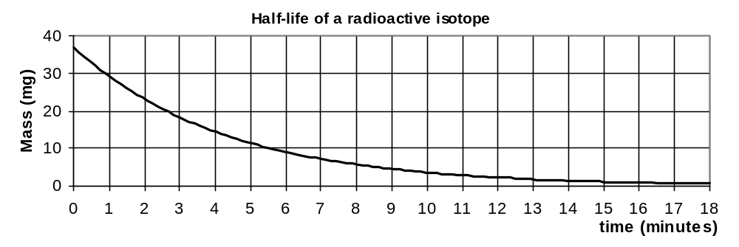

Half-life = ______________________________

- In the following reaction 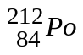 → X + an α particle; the nuclide X is: (1 mark)
A. 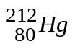 B. 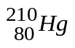 C. 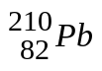 D. 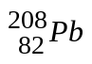 E. 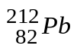
Answer: ____________

- If a radioactive sample has a half-life of 1.50 hours. If the activity of the sample was originally 15.0 kBq, what would the activity be exactly one day later? (2 marks)

- The radio isotope 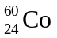has a half-life of approximately 5.00 years. Gamma radiation from a source is used to treat cancer. Hospitals using such sources for therapy usually replace the source when its activity has fallen to 25% of its original value. After how many years must a source be replaced? All working must be shown. (2 marks)

- Household smoke detectors contain a radioactive Americium-241 source. Emitted radiation ionizes air inside a chamber that allows a small current to flow. Smoke particles entering the chamber interrupt the current flow, which sets off the alarm. Americium-241 is an α emitter with a half life of 433 years.

  - Using the information above, briefly discuss why 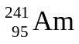 is ideal for use in smoke detectors.
____________________________________________________________________________
____________________________________________________________________________
____________________________________________________________________________
____________________________________________________________________________
____________________________________________________________________________
____________________________________________________________________________
____________________________________________________________________(2 marks)
  - What would you say to a person who is anxious about having a smoke detector containing a radiation source in their home? (2 marks)

____________________________________________________________________________
____________________________________________________________________________
____________________________________________________________________________
____________________________________________________________________________
____________________________________________________________________________
____________________________________________________________________________
____________________________________________________________________________

